1. Install SQL server
2. Install SQL workbench – for viewing the DB
3. Create a DB

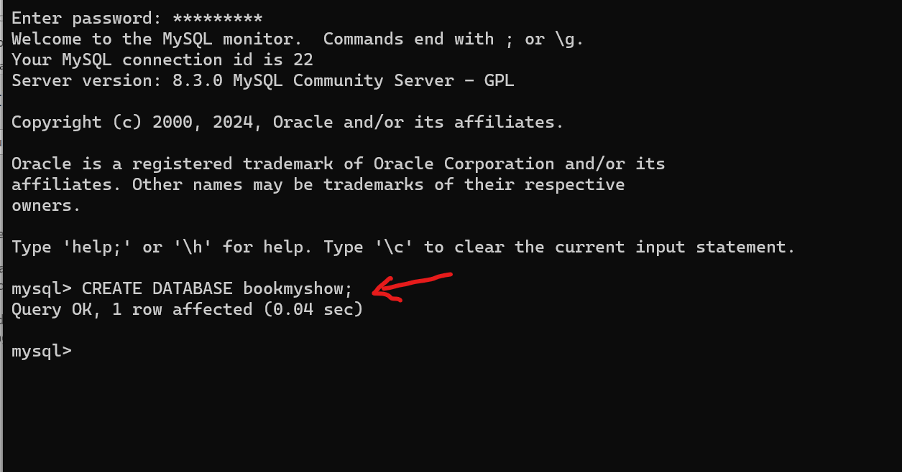

1. Npm start:

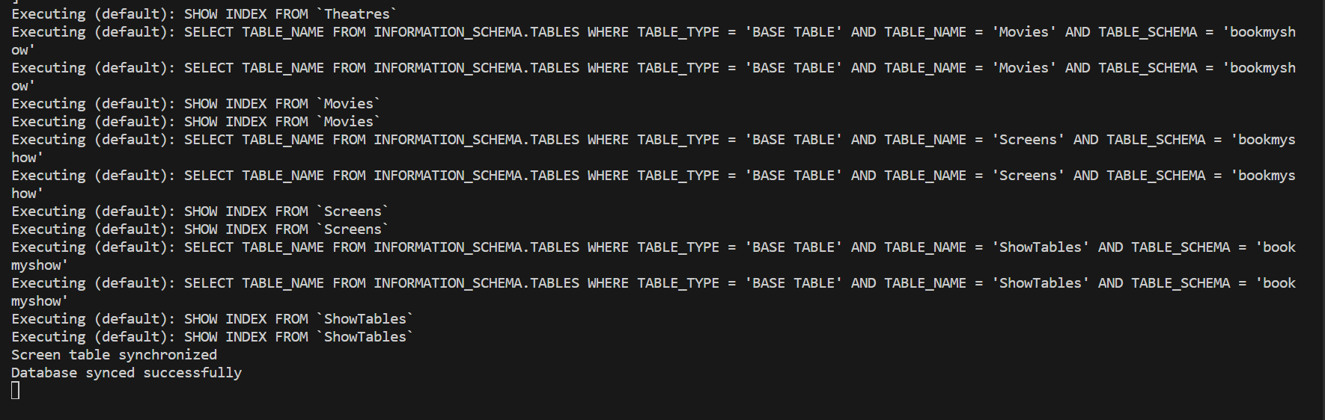

Queries are executed and table is created

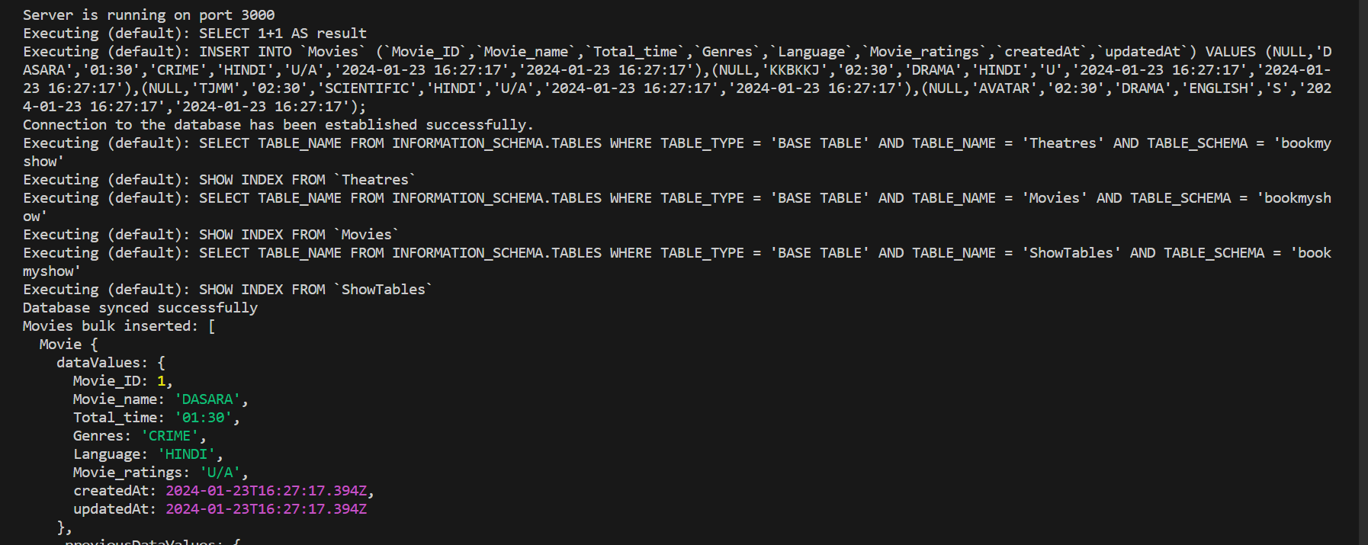

Viewing movies Table in Database:

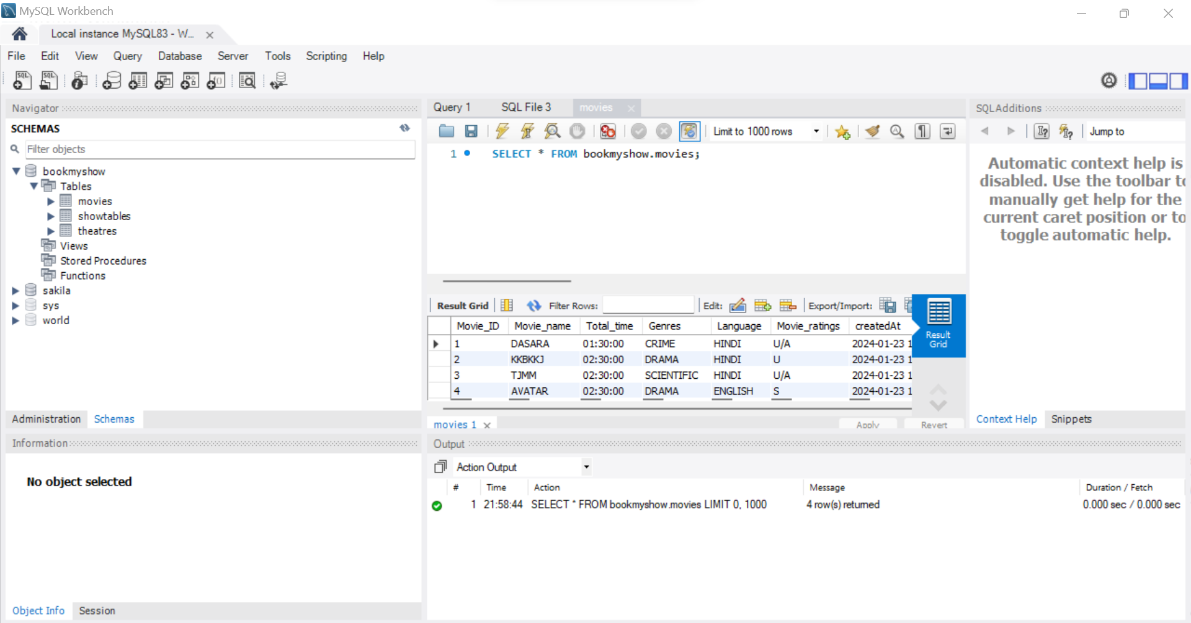

Theatre Table:  
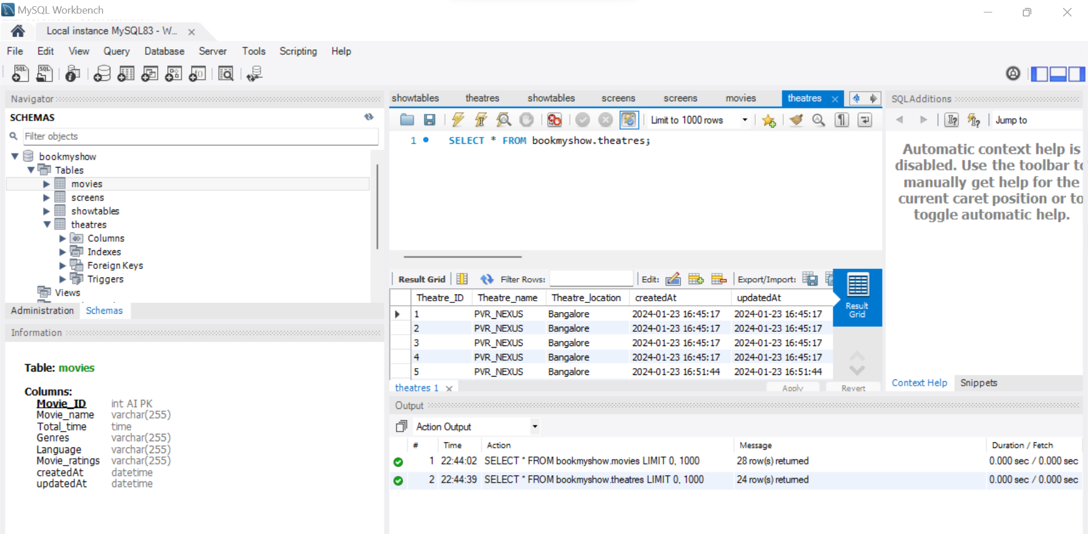  
  
ShowTable:  
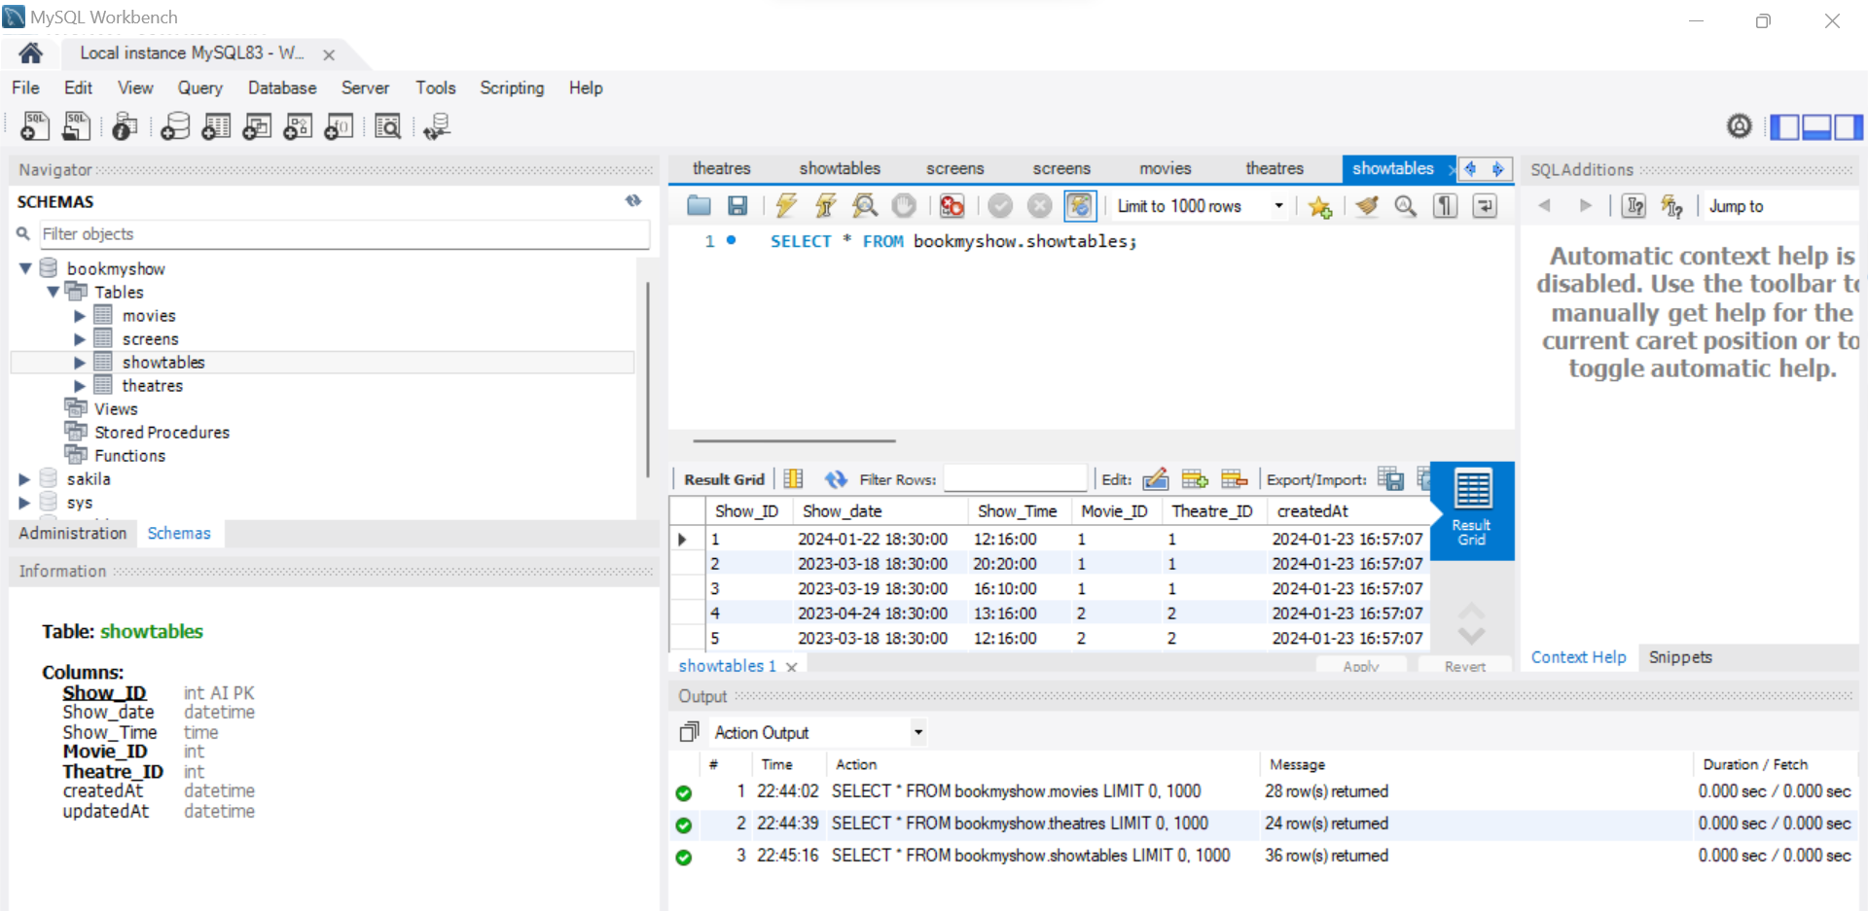  
  
Screen:

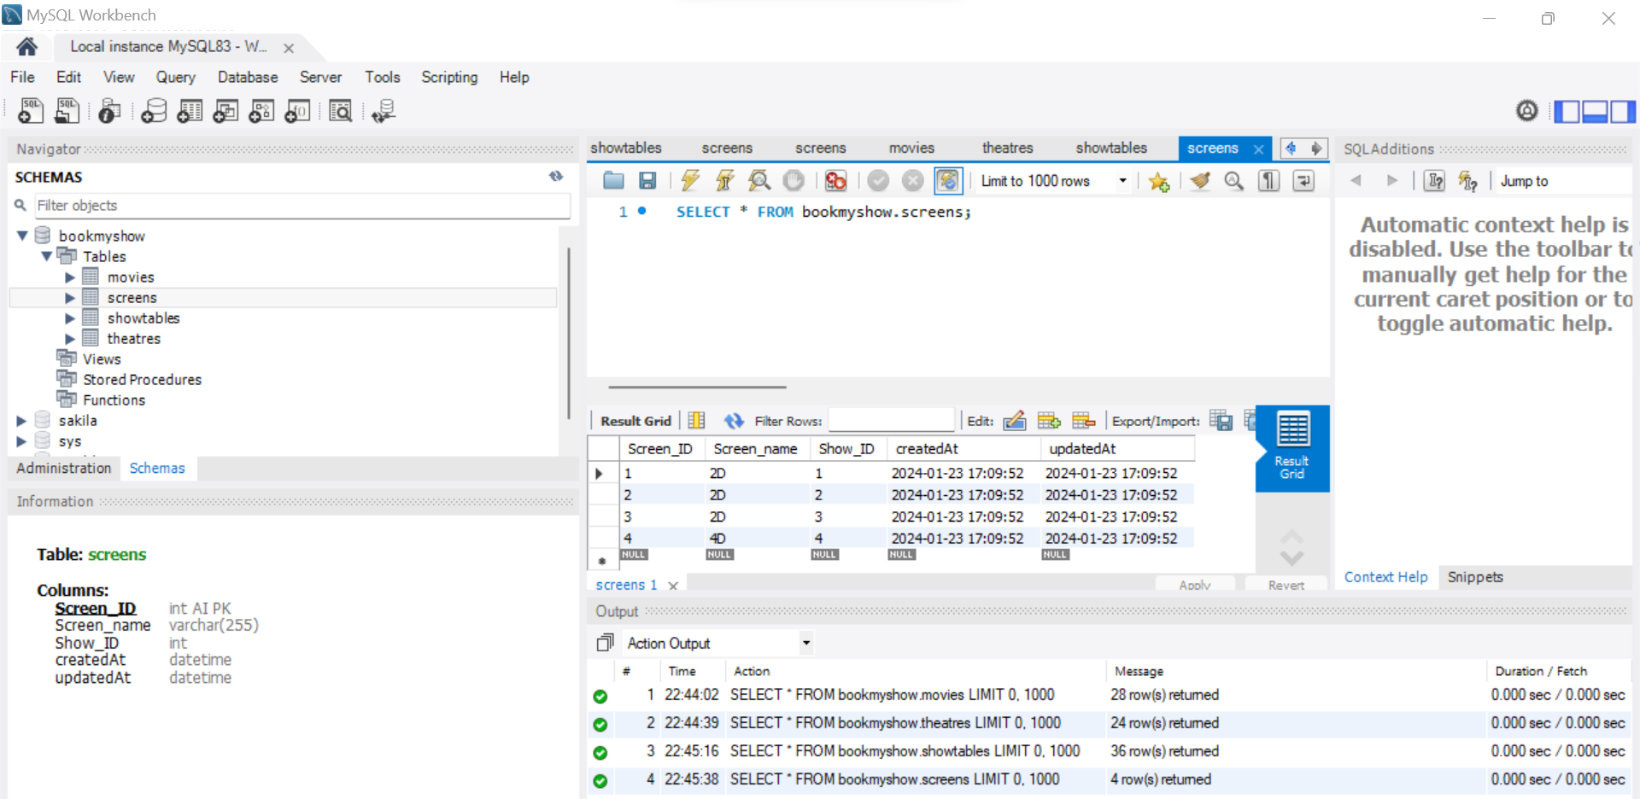

Seat:  
  
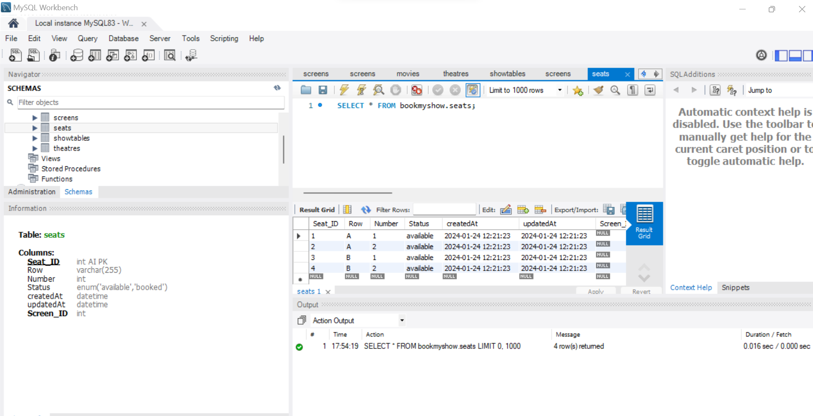

User:

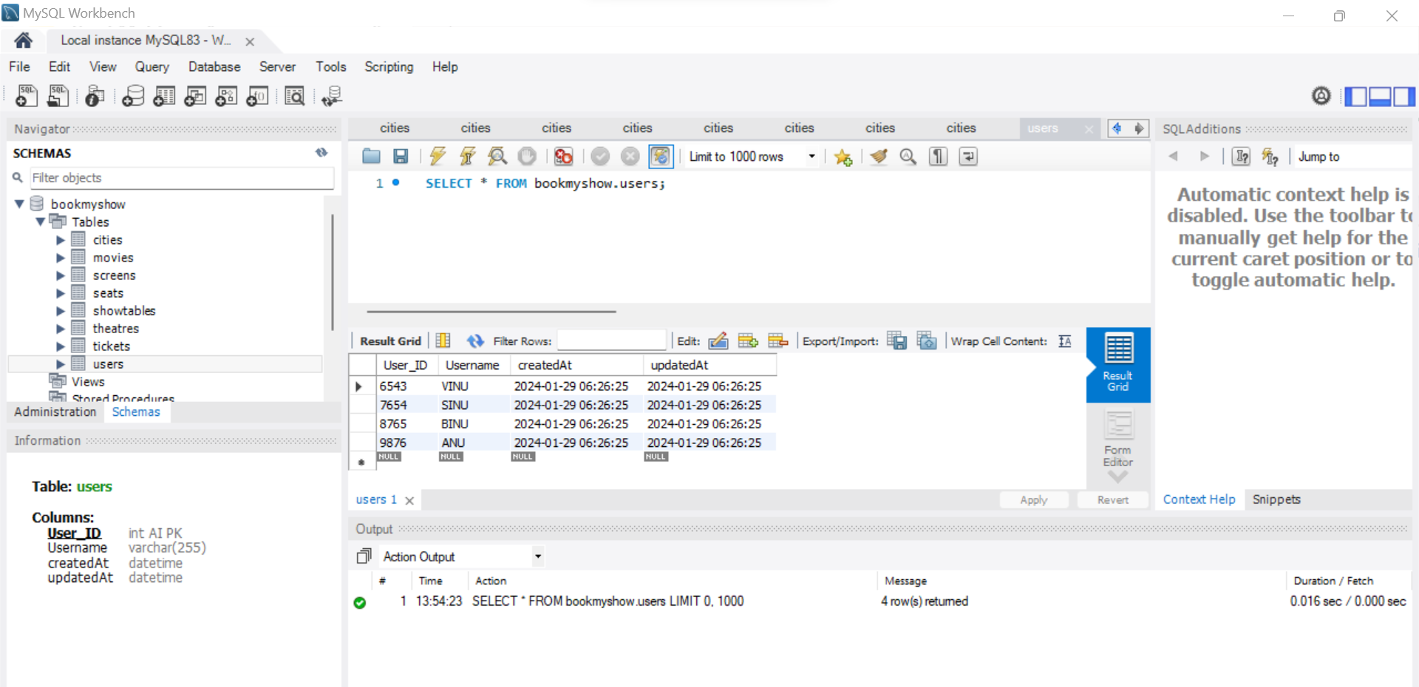

Ticket:

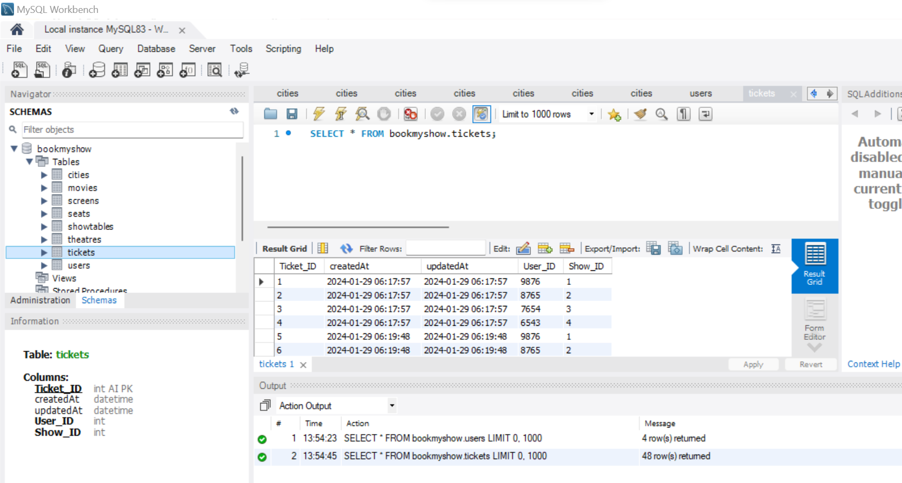

City:

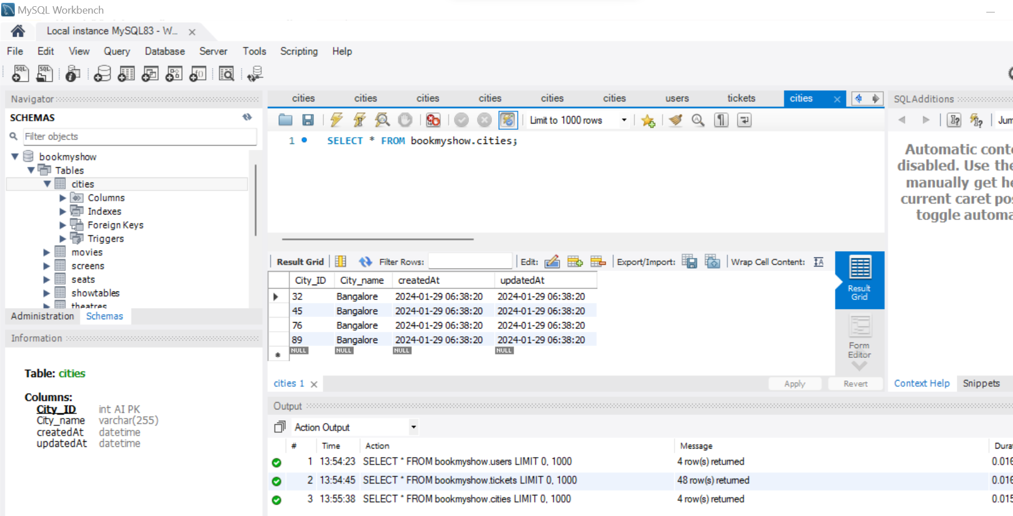

2] Associations between the entities: (1:1, 1:M, M:M)

Theatre, Movie, Screen, Show, Ticket, City

City : Theatre – 1:M

Theatre : Show(3HR) – 1:M / Screen : Shows – 1: M

Theatre : Screen – 1: M

User : Ticket -1:M

Show : Movie – 1:1

Seat(normal, premium, delux): Screen (1:M) / Show: Seat (1:M)

……………………………………………………………………………..

Associations in ORM – takes care of foreign key constraints

1: 1

HasOne/ BelongsTo

Show.HasOne(Movie);

Movie.BelongsTo(Show);

//////////////////////////

1:M

HasMany & BelongsTo

City.HasMany(Theatres)

Theatre.BelongsTo(City)

//////////////////

M:M

HasMany & BelongsToMany